Available Now - RBDigital Unlimited Newspapers

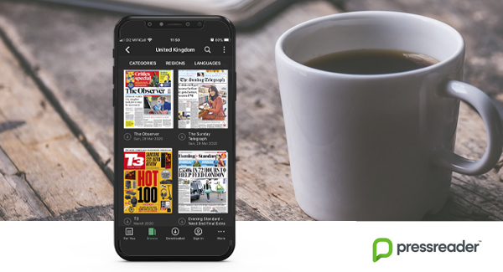

Weblink: http://dundee.rbdigitalglobal.com/home

New to our RBDigital Service – free access to full text of thousands of newspapers from over 100 countries every day. Local newspapers The Courier and Dundee Evening Telegraph are included and with a press of a button you can even translate foreign language favourites from their original language into more than 16 alternatives.

Existing Dundee Library RBDigital Users

Sign in to your RBDigital Account here http://dundee.rbdigitalglobal.com/home ,
Scroll down to Newspapers and press Access to be directed to the unlimited newspaper collection.

Or if you use the RBDigital App simply log out and back in with the username and password you created. Select Newspapers from the Menu bar and click the Checkout then Access buttons to be directed to the unlimited newspaper collection.

New to Dundee Library RBDigital?

Create an account using your library card number and PIN through our website
or
Download the free RBDigital App to your device, choose library service Leisure & Culture Dundee then enter your library card and other requested details to create an account. Read the quick start up guide here.

I'm not a library member, can I join?
If you haven’t been a library member before, or it’s been a while, then this is the time to develop your reading habit. Join online for free and access a wide range of digital reading via our RBDigital and BorrowBox services.
We will look forward to meeting you in person and upgrading your membership once normal service resumes.

